Geotechnical Services

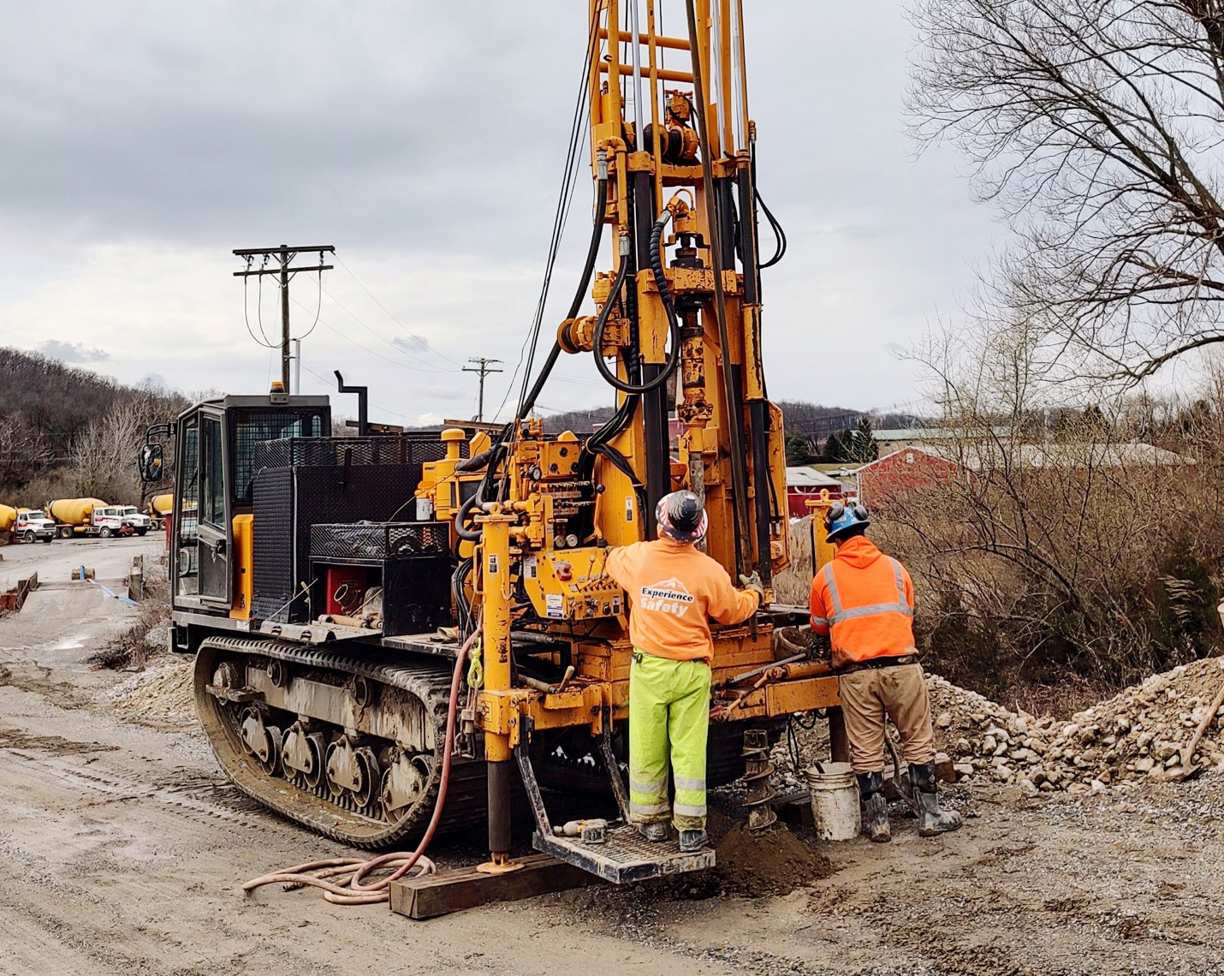

[Icon] INDUSTRIES SERVED
Geotechnical Services
We help you strengthen every project from the ground up

[Main content well]
From large construction projects to solar carports, Summit’s geotechnical services offer talented and licensed drillers, a diverse equipment fleet of truck and track mounted rigs, and decades of project management experience in all types of geological conditions.

Our Geotech Services include:
• Standard penetration testing and soil borings
• Rock Coring NQ and HQ
• Piezometers
• Inclinometers
• Extensometers
• Vibrating wire piezometers
• Undisturbed Sampling-Shelby Tube Samples
• Vane Shear Testing
• Packer Testing
• Test Pits
• Permeability & Infiltration testing

Summit brings over 50 years of drilling experience to multiple industries, such as major petroleum, commercial construction, railroads, highway projects, telecommunications, and renewable energy.

We’ll contribute to your approach and provide a prompt and cost-effective proposal. Count on Summit for An Exceptional Experience.

Summit’s Lauren DiVello is a dedicated and experienced customer advocate. Reach Lauren at 609-238-2815 to discuss your project needs. Or email LDivello@SummitDrilling.com and she will reply promptly.

[Stat-a-Project Form]

